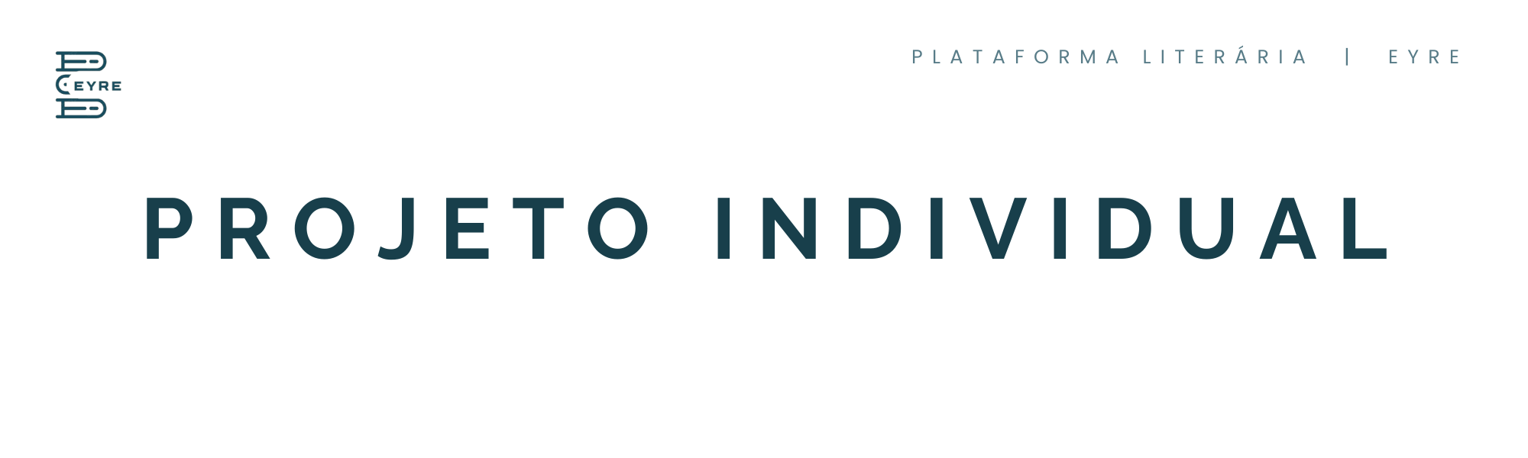

**Links do projeto:**

* **Github :**

<https://github.com/sara-nsantos/projeto-individual-livros>

* **Trello**

<https://trello.com/b/L2gCPW0I/projeto-individual>

* **Apresentação do projeto**

<https://www.canva.com/design/DAGHMlcnac8/vaLWJ47NNo8dFkaFXVUPFQ/edit?utm_content=DAGHMlcnac8&utm_campaign=designshare&utm_medium=link2&utm_source=sharebutton>

* **Documentação :**

[**Eyre - Projeto individual.docx**](https://bandteccom-my.sharepoint.com/:w:/g/personal/sara_santos_sptech_school/EaVeAQHhvSNDqS_SNPauvCMBk0MNJGgKDL5DQTNyq69r9Q?e=CjRZLa)